1. **Informatica University:**

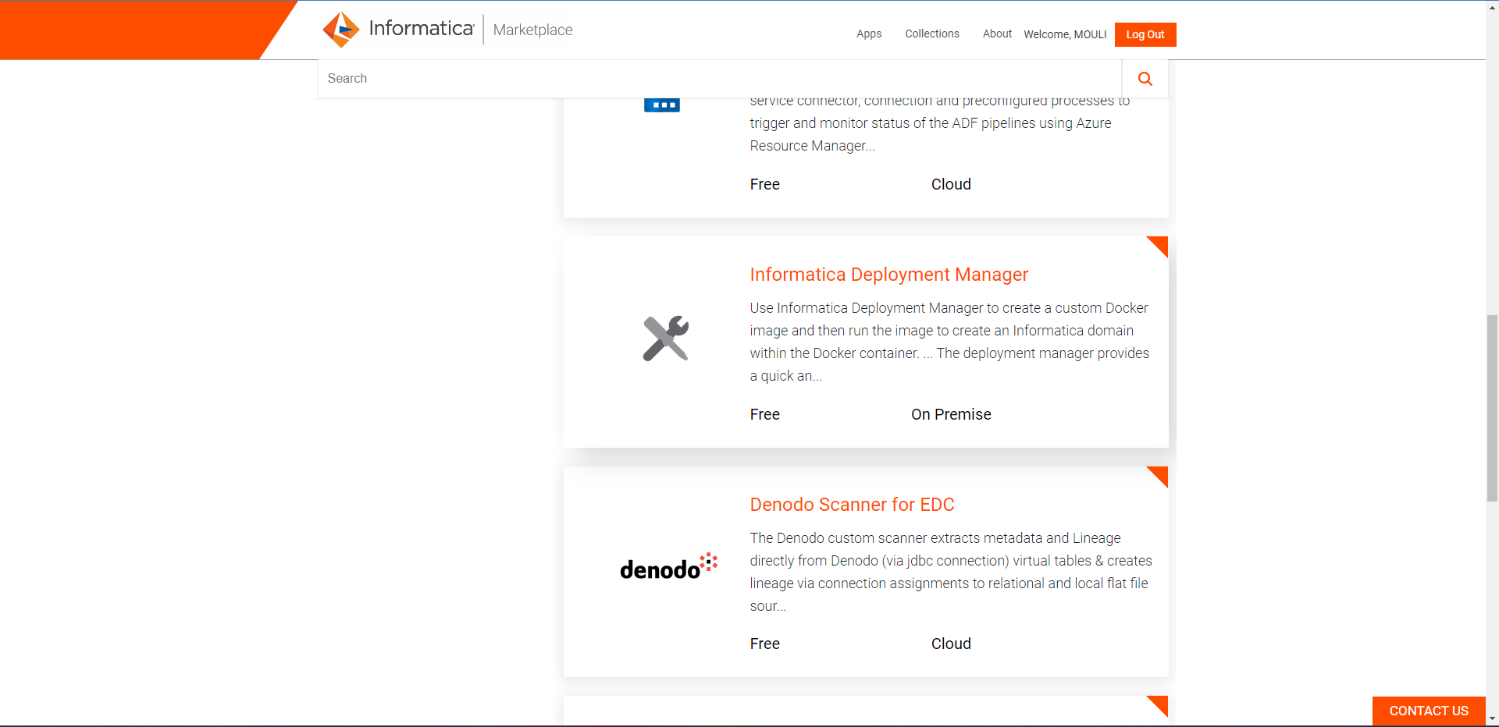

1. **SQL Question:**

**Query:**

USE [Hexaware];

SELECT * FROM [dbo].[emp];

SELECT

SUM(CASE WHEN sal > 5000 THEN sal * 0.1 ELSE sal * 0.15 END) AS total_commission,

(SUM(CASE WHEN sal > 5000 THEN sal * 0.1 ELSE sal * 0.15 END) / SUM(sal)) * 100 AS percent_extra_money

FROM [dbo].[emp]

1. **IICS Access:**
   1. **30 days trail**

**b.**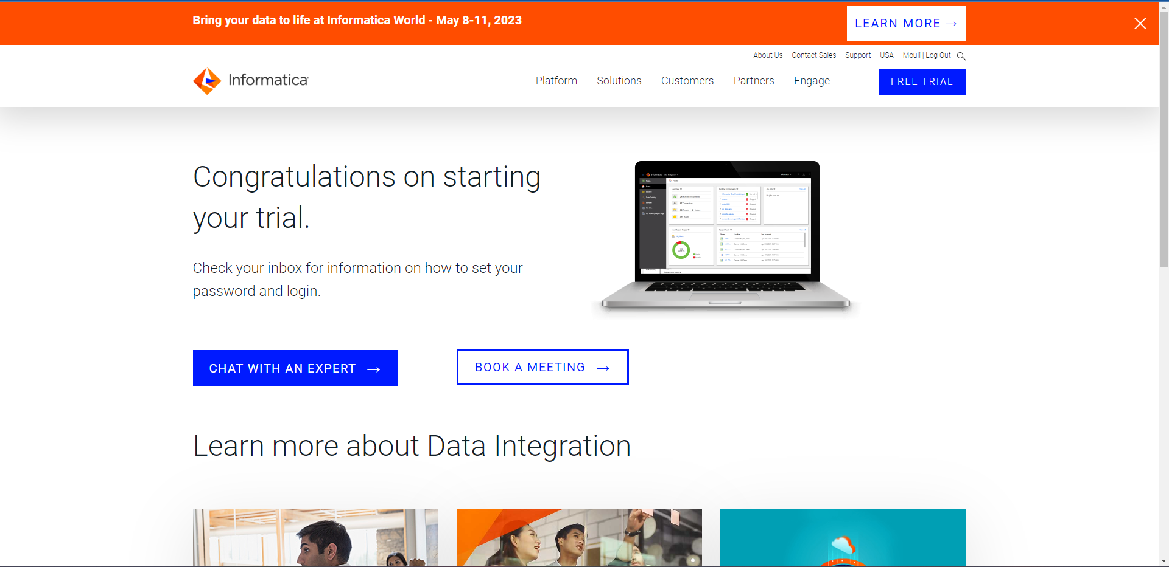

1. **ETL**
   * 1. **Summary**

• Stands for Extract, Transform and Load

• Data integration process which process the data from multiple sources in to the single system.

• Load the data into the data warehouse or target system

**ETL Explanation**

• Extract the data from source.

• Cleanse the data to improve the quality and consistency.

• Load data to target database.

**ELT Comes in play**

• ELT is different from ETL by order of operations

• Extract the data from source.

• Load data to target database.

• Transformed when it is needed.

**Extraction Process**

• During data extraction, raw data is copied or exported from source locations to a staging area.

• Data management teams can extract data from a variety of data sources, which can be structured or unstructured

**Transform Process**

• Filtering, cleansing, de-duplicating, validating, and authenticating.

• Performing calculations, translations, summarization.

• Conducting audits.

• Removing, encrypting and formatting.

**Load Process**

• transformed data is moved from the staging area into a target data warehouse

• this process done in the lowest traffic hours.

**Change Data Capture (CDC)** identifies and captures only the source data that has changed and moves that data to the target system. CDC can be used to reduce the resources required during the ETL “extract” step; it can also be usedindependently to move data that has been transformed into a data lake or other repository in real time.

1. 